Scrum Buddies Process Document

Group Software Engineering Project (ECM2434): Persuasive Gamification of Sustainability on Campus

**Group of 6 Decided (29/01/24)**

Achille Fossiez-Revenu, Charlie Silver, Greg Goursaud, Liam Buchanan, Luke Hales, Will Smith

Team Name: Scrum Buddies

**Important Links:**

Link to Trello Kanban Board - <https://trello.com/b/9S5p6byz>

Link to GitHub repo – <https://github.com/CharlieSilver1108/Sustainability-Game>

**Records of Meetings throughout the Project:**

**First meeting – Led equally amongst group members (10/02/24) – 45min**

- Ice Breaker session, get to know teams’ members

-Going through Project Specification

-First discussions on visions and epics for our app and what it would look like

-Brainstorming session, Outline of project and loose MoSCoW outline.

**Group Clinic 1 (12/02/24) -15min**

-Initial group meeting with module coordinator to discuss visions and epics of the project

**Group Meeting – Led by Greg Goursaud (12/02/24)-10min**

-Follow up meeting from clinic to further discuss ideas and distribution of work

**Group Meeting – Led by Charlie Silver (14/02/24)- 20min**

-Official setup of kanban board using Trello

-Creation of GitHub repository along with separate branches for each team member

-Implementation of validation of push commits (pull requests also) to main to avoid losing any content unintentionally

**Group Meeting – Led by Luke Hales (16/02/24) -15min**

-Initial assigning of cards on Kanban board to different members (see snapshot 2 later on)

-Making sure everyone can pull/push onto GitHub

**Group Meeting – Led by Achille Fossiez-Revenu (18/02/24) -15min**

-General meeting, talking about potential challenges and problems

-Reporting on what team members have worked on and will work in

**Group Clinic 2 (19/02/24)**

-Second group clinic meeting with module coordinator to discuss next steps and progress towards minimum viable product

**Group Meeting – Led by Charlie Silver (19/02/24) – 10min**

-Updating Kanban board for more streamlined kanban board (see Kanban snapshots later)

-Further discussing ideas from advice given in Group Clinic with module leader

**Group Meeting – Led by Liam Buchanan (21/02/24) – 15min**

-General meeting, reporting on what team members have worked on and will work on

**Group Meeting – Led by Will Smith (23/02/24) – 15min**

-Progress towards MVP check, testing of website

-Working out what needs to be done before fist submission (29th feb)

**Group Meeting – Led by Achille Fossiez-Revenu (21/02/24) – 15min**

-General meeting, talking about any challenges and problems

-Reporting on what team members have worked on and will work on

**Group Meeting – Led by Greg Goursaud (25/02/24)-20min**

- Testing of minimum viable product to make sure everything works ahead of 3rd group clinic

**Group Clinic 3 (26/02/24)**

-Third group clinic meeting with module coordinator, looking at what needs to be done before MVP submission and Kanban board check

**Group Meeting – Led by Will Smith (26/02/24) – 10min**

-Following up on points made in Clinic

-Distributing of final tasks before MVP submission to make sure submission consists of everything we want

**Group Meeting – Led by Luke Hales (27/02/24) – 15min**

-Planning MVP submission

-Allocation of different documents for submission between members

**Group Meeting – Led by Liam Buchanan (28/02/24) – 20min**

-Final Meeting to check contents for first submission is all ready

-Review of Process Doc, Product Doc and Tech Doc

**28/02/24- First Submission and Group Peer Review Form completed by each member**

**Problems faced so far, with Solutions:**

Miscommunication between 2 members led to the “update account” card on the Kanban Board being worked on by 2 different people. Luckily problem was uncovered in the following group meeting before a lot of time was wasted.

On the rare occasion a team member wasn’t available to meet up for the group meetings, the meetings still went ahead. So that such problems (e.g. illnesses) didn’t slow down the team’s progress, notes of meetings were then summarised in group chat by meeting leader to make sure everyone was on the same page.

Challenge confronted with merging branches for a team member where separate database setup could not be merged at the same time, but resolved during the next group meeting.

**Kanban Board progression in chronological order:**

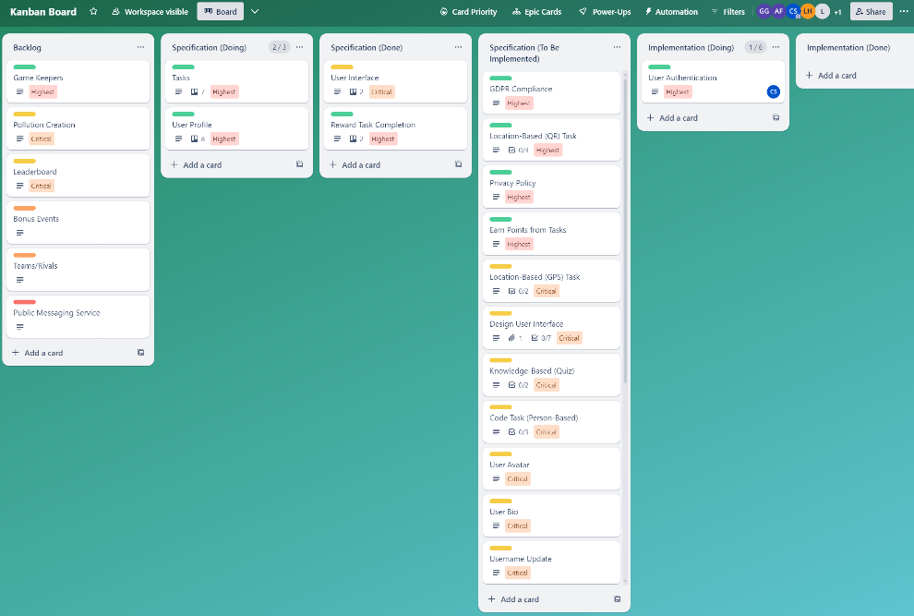Snapshot 1: (16/02/24)

Snapshot 2: (21/02/24)

Snapshot 3: (25/02/24)

Snapshot 4: (28/02/24)

